

The Department of Computer Science & Engineering (CSE)
(Odd Sem 2025-26)
Project Report On

“Financial Fraud Detection”
(Minor Project, BCA-507)
Submitted to
The Department of CSE
In partial fulfillment of the requirements for the award of the
BCA
By
Mohit Kumar (SBU232941), Sem- V , Section-D

Under the guidance of

Bonafide Certificate
This is to certify that the project report titled “Financial Fraud Detection System” submitted by:
- Mohit Kumar (SBU232941), Sem–V, Section-D
is a bonafide record of work carried out by them under my supervision in partial fulfillment of the requirements for the award of the degree of Bachelor of Computer Applications (BCA) at Sarala Birla University for the academic session 2025–26.

Sign:______________

Date:
(Dr. Prakash Kumar)
Assistant Professor

Department of CSE
Sarala Birla University, Ranchi

Declaration

We hereby declare that the project titled “Financial Fraud Detection System” submitted in partial fulfillment for the award of the degree of Bachelor of Computer Applications (BCA) at Sarala Birla University is an original work carried out by us under the guidance of Dr.Prakash Kumar, Assistant Professor , Department of CSE.
We also declare that this project has not been submitted earlier to any other institution or university for the award of any degree or diploma.
Mohit Kumar (SBU232941)

Signature:
Date:
Mohit Kumar
SBU232941

Acknowledgement

We are profoundly grateful to Sarala Birla University and the Department of Computer Science & Engineering (CSE) for providing us with the opportunity to work on this minor project titled “Financial Fraud Detection System.”
This project has been a highly enriching learning experience for us.
We express our deepest gratitude to our project guide, Dr. Prakash Kumar, Assistant Professor, Department of CSE, for his constant support, valuable guidance, constructive feedback, and continuous encouragement throughout the project. His expertise and suggestions greatly helped us in shaping this work and improving our understanding of the subject.
We would also like to thank all the faculty members of the CSE Department for their support, cooperation, and for creating a motivating academic environment.
Our sincere thanks to our classmates and friends for their suggestions, technical help, and encouragement during the course of this project.
Finally, we are thankful to our parents and family members for their constant motivation, blessings, and emotional support, without which this project would not have been possible.
Mohit Kumar

Mohit Kumar- SBU232941
Program: BCA
Semester: V
Section: D
Batch: 2023–26

TABLE OF CONTENTS
Chapter No. | Title | Page No.
Abstract | i
Acknowledgement | ii
Declaration | iii
Bonafide Certificate | iv

Chapters
| 1 | Introduction | 1 |
| 1.1 | Overview of Financial Fraud | 2 |
| 1.2 | Problem Statement | 3 |
| 1.3 | Need for Fraud Detection | 4 |
| 2 | Aim and Scope | 5 |
| 2.1 | Aim of the Project | 6 |
| 2.2 | Objectives | 7 |
| 2.3 | Scope of the Project | 8 |
| 3 | System Design & Methodology | 9 |
| 3.1 | Existing System | 10 |
| 3.2 | Proposed System | 11 |
| 3.3 | System Modules | 12 |
| 3.4 | System Architecture | 13 |
| 3.5 | Data Flow Diagram | 14 |
| 4 | Software Development Methodology | 15 |
| 4.1 | Development Approach | 16 |
| 4.2 | Algorithms Used | 17 |
| 4.3 | Model Training and Testing | 18 |
| 5 | Results and Discussion | 19 |
| 5.1 | Experimental Results | 20 |
| 5.2 | Performance Analysis | 21 |
| 6 | Conclusion and Future Work | 22 |
| 6.1 | Conclusion | 23 |
| 6.2 | Future Enhancements | 24 |
References
Appendix

**CHAPTER 1
INTRODUCTION**
Financial fraud has emerged as one of the most critical challenges in today’s digital world. With the rapid growth of online banking, mobile payments, e-commerce transactions, and digital financial services, the number of fraudulent activities has also increased significantly. Fraudsters continue to develop new methods of exploiting vulnerabilities in financial systems, leading to substantial monetary losses for individuals, businesses, and financial institutions.
Financial fraud includes a variety of deceptive practices such as identity theft, unauthorized transactions, credit card fraud, fake loan applications, phishing, transaction manipulation, and synthetic identity creation. Traditional fraud detection systems rely heavily on manual checks or fixed rule-based mechanisms. While these methods can detect basic forms of fraud, they are often ineffective against advanced or emerging fraud patterns. As financial datasets become larger and fraud techniques become smarter, there is a growing need for systems that can automatically learn, identify, and adapt to suspicious behavior.
Machine learning has become one of the most effective tools in combating modern financial fraud. By analyzing historical data, discovering hidden patterns, and identifying anomalies, machine learning models can detect suspicious transactions more accurately and quickly than conventional methods. These models can classify transactions as genuine or fraudulent based on previous patterns, helping organizations reduce financial risks, protect customer data, and maintain a secure digital environment.
This project, “Financial Fraud Detection,” focuses on developing an intelligent fraud detection model using data analysis and machine learning techniques. The goal is to build a system that can detect unusual transaction behavior, identify fraud in real time, and minimize false alarms. The project involves various stages including data preprocessing, feature extraction, algorithm selection, model training, evaluation, and result analysis.
This chapter gives an overview of the concept of financial fraud, highlights the need for advanced fraud detection mechanisms, and explains how machine learning enhances fraud prediction. The aim is to provide a strong foundation for understanding the objectives, design, and implementation of the fraud detection system developed in this project.
1.1 PROBLEM STATEMENT
With the increasing usage of online banking, digital wallets, UPI payments, and credit or debit card transactions, there has been a significant rise in financial fraud cases. Traditional fraud detection systems rely on manual verification or static rules, which fail to accurately identify new and evolving fraud patterns. These systems often generate high false positives, causing inconvenience to genuine users, or worse—fail to detect actual fraudulent transactions.
Financial institutions handle millions of transactions daily, making manual monitoring practically impossible. Fraudsters use advanced techniques such as identity theft, card skimming, phishing, and transaction manipulation, which demand modern detection methods. Therefore, the key problem is to design an automated, accurate, and scalable system that can:
- Detect fraudulent transactions in real time
- Adapt to new fraud patterns
- Reduce financial losses
- Minimize false positive alerts
This project aims to address these issues through machine learning–based fraud detection.

1.2 NEED FOR THE STUDY
The need for efficient fraud detection mechanisms has become more pressing due to:
1. Rapid digital transformation
The world is shifting toward online financial services, increasing the chances of cyber fraud.
2. Increasing financial losses
Banks and customers suffer massive monetary losses due to undetected frauds.
3. Limitations of traditional systems
Rule-based systems cannot detect sophisticated fraud patterns or adapt to new methods used by criminals.
4. Vast and complex financial data
Large datasets require automated systems capable of learning patterns and identifying anomalies.
5. Requirement for real-time detection
Fraud needs to be detected immediately to prevent unauthorized transactions.
Machine learning provides powerful techniques to analyze transaction behaviors and detect fraud with high accuracy. Hence, a study focused on ML-based fraud detection is essential.

1.3 OVERVIEW OF THE PROJECT
This project investigates how machine learning can be applied to detect financial fraud effectively. It focuses on analyzing transaction data, building predictive models, and detecting anomalies that indicate fraudulent behavior.
Key activities in this project include:
- Understanding how financial fraud occurs
- Collecting and preprocessing transaction data
- Identifying important features related to fraud
- Training classification and anomaly detection models
- Evaluating accuracy, precision, recall, and F1 scores
- Implementing fraud detection logic for prediction
- Analyzing results and improving the model
Technologies Used
- Machine Learning Algorithms
- Python (optional depending on system)
- Data Preprocessing Methods
- Exploratory Data Analysis (EDA)
Expected Outcome
A fraud detection model capable of accurately identifying suspicious transactions, reducing false alerts, and improving the security framework of digital financial systems.
**CHAPTER 2
AIM AND SCOPE**

2.1 AIM OF THE PROJECT
The primary aim of this project is to design and develop an intelligent system capable of detecting financial fraud using machine learning techniques and data analysis. The system should classify transactions as fraudulent or genuine by identifying unusual patterns, irregular behavior, and suspicious anomalies within financial data.
This project aims to:
- Enhance fraud detection accuracy
- Reduce false alarms in fraud identification
- Improve the overall security of financial transactions
- Assist financial institutions in preventing monetary loss
- Provide a scalable and automated fraud detection solution

2.2 OBJECTIVES
The major objectives of this project are:
1. To study various types of financial fraud
Understand how fraud occurs in real-world financial systems such as banks, online payments, and e-commerce.
2. To analyze and preprocess financial transaction datasets
Clean, normalize, and structure data to improve model training and accuracy.
3. To identify relevant features that indicate fraud
Examine patterns such as transaction amount, time, frequency, location, and user behavior.
4. To evaluate different machine learning algorithms
Test algorithms like Logistic Regression, Decision Trees, Random Forest, and SVM for fraud classification.
5. To build a predictive model
Train a machine learning model capable of identifying suspicious transactions automatically.
6. To analyze model performance
Use metrics such as accuracy, precision, recall, and F1 score to determine effectiveness.
7. To develop a fraud detection framework
Provide a system that can be applied in real-time financial environments.

2.3 SCOPE OF THE PROJECT
The project has a wide scope and can be extended to various financial domains. The system can be used for:
1. Banking
Detect unauthorised transactions, suspicious withdrawals, and credit card fraud.
2. Online Payment Platforms
Identify unusual payment behavior on UPI apps, digital wallets, and payment gateways.
3. E-commerce
Identify fake transactions, abnormal purchases, and fraud attempts during checkout.
4. Insurance Sector
Detect fraudulent insurance claims based on unusual patterns.
5. Loan Applications
Identify fake documents or fraudulent borrowers using behavioural data.
6. Real-time alert systems
Integrate with mobile apps or banking software to warn users instantly.

2.4 LIMITATIONS
While effective, the system has certain limitations:
- Accuracy depends on the quality of the dataset
- Models may require continuous training
- Extremely new fraud patterns may be harder to detect
- Large datasets demand high computational resources

2.5 ADVANTAGES
- Fast and automated fraud detection
- Improved accuracy compared to manual systems
- Reduces financial losses
- Detects hidden and complex patterns
- Can adapt to new fraud techniques
- Helps maintain customer trust and system reliability
**CHAPTER 3
SYSTEM DESIGN & METHODOLOGY**
A well-structured system design is essential for developing an efficient fraud detection model. This chapter explains the existing challenges, the proposed system, the modules involved, architectural design, and the methodology used to detect financial fraud.

3.1 EXISTING SYSTEM
Traditional financial fraud detection systems rely mainly on:
1. Rule-Based Techniques
Fraud is detected based on predefined rules such as transaction limits, unusual locations, or flagged behaviors.
2. Manual Verification
Human analysts manually inspect suspicious transactions and approve or decline them.
3. Static Thresholds
Transactions above a certain amount or frequency are flagged as suspicious.
However, these systems have significant drawbacks:
- Unable to detect new or advanced fraud techniques
- High false positives (genuine transactions marked as fraud)
- Time-consuming and inefficient
- Cannot analyze massive real-time transaction data
- Lack of adaptability
Due to these limitations, traditional systems fail to protect users from modern, sophisticated financial fraud.

3.2 PROPOSED SYSTEM
The proposed system uses machine learning algorithms to automatically detect suspicious transactions based on patterns and anomalies found in financial data.
Key Features of the Proposed System:
- Learns from historical transaction data
- Automatically identifies hidden fraud patterns
- Detects anomalies without manual intervention
- Reduces false positives
- Provides real-time fraud detection capabilities
- Scalable for large datasets
Main Idea:
Instead of relying on fixed rules, the system learns from data to differentiate between genuine and fraudulent behavior.

3.3 SYSTEM MODULES
The proposed fraud detection system is divided into the following modules:

1. Data Collection Module
- Gathers financial transaction data
- Includes features like amount, location, time, transaction type, account balance, etc.

2. Data Preprocessing Module
- Removes missing or duplicate values
- Converts categorical values into numerical form
- Normalizes large numeric differences
- Selects important features contributing to fraud
This ensures that the model is trained on clean, high-quality data.

3. Machine Learning Module
This is the core component of the project.
Various machine learning algorithms are applied such as:
- Logistic Regression
- Decision Tree
- Random Forest
- Support Vector Machine (SVM)
- Neural Networks (optional extension)
The model learns transaction behavior and identifies fraudulent patterns.

4. Fraud Detection Engine
- Predicts whether a new transaction is fraudulent or genuine
- Uses trained ML models to classify transactions
- Helps financial institutions take quick decisions

5. User Interface / Output Module
- Displays prediction results
- Shows transaction details
- Presents analysis graphs and model metrics

3.4 SYSTEM ARCHITECTURE
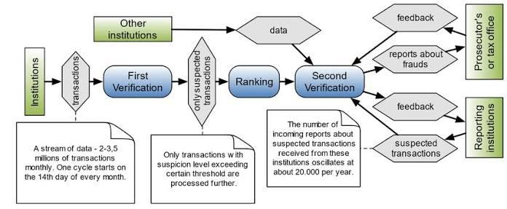
- Input: Transaction Dataset
- Preprocessing: Clean and prepare the data
- Machine Learning Model Training
- Fraud Detection Prediction
- Output: Fraud or Genuine
This architecture provides a structured flow from data input to fraud prediction.

3.5 DATA FLOW DIAGRAM (DFD)
Level 0 (Context Diagram):
- User submits transaction → System analyses → Output: Fraud / Not Fraud
Level 1 DFD:
- Data Input
- Preprocessing
- Model Training
- Fraud Detection
- Result Generation

3.6 METHODOLOGY
The system follows a systematic approach:

Step 1: Data Collection
Collect real or publicly available financial transaction datasets.

Step 2: Data Preprocessing
- Remove noise
- Normalize values
- Apply feature selection
- Split data into training and testing sets

Step 3: Exploratory Data Analysis (EDA)
- Analyze fraud percentage
- Identify patterns in transaction data
- Visualize transaction behaviors

Step 4: Model Training
Train several machine learning models using the processed dataset.
Choose the best model based on accuracy and performance metrics.

Step 5: Model Evaluation
Evaluate the model using:
- Accuracy
- Precision
- Recall
- F1 Score
- Confusion Matrix
These metrics determine whether the model correctly identifies fraudulent transactions.

Step 6: Prediction
The optimized model is then used to predict new transactions as:
- Fraudulent
- Genuine

Step 7: Output & Reporting

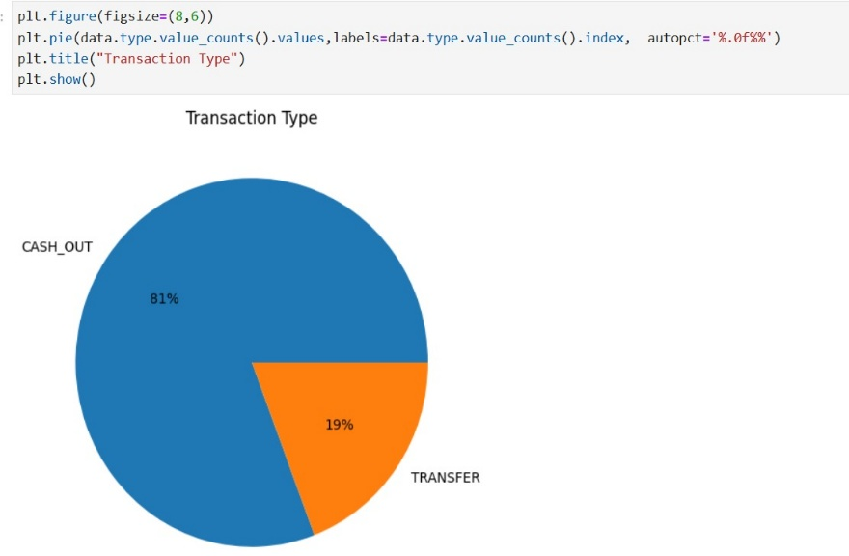
**CHAPTER 4
SOFTWARE DEVELOPMENT METHODOLOGY**
This chapter explains the software development approach, technologies used, tools required, and the machine learning algorithms implemented for detecting financial fraud. It outlines the step-by-step process followed to build the fraud detection system.

4.1 SOFTWARE DEVELOPMENT LIFE CYCLE (SDLC)
The project follows the Machine Learning Development Lifecycle (MLDLC) combined with a structured SDLC approach. The major phases include:
✔ 1. Requirement Analysis
- Understanding financial fraud types
- Identifying key features in transaction datasets
- Determining system goals: accuracy, efficiency, and scalability
✔ 2. Data Collection
- Collecting transaction data
- Gathering fraud vs genuine transaction samples
✔ 3. Data Preprocessing
- Cleaning, transforming, and normalizing data
- Handling missing values
- Removing noise
- Feature scaling and selection
✔ 4. Model Building
- Selecting suitable machine learning algorithms
- Splitting data into training and testing sets
✔ 5. Model Training
- Feeding training data to ML algorithms
- Adjusting parameters to improve accuracy
✔ 6. Model Testing & Evaluation
- Using testing data to verify performance
- Evaluating using accuracy, precision, recall, and F1-score
✔ 7. Deployment / Prediction Phase
- Using the trained model to classify new transactions
- Generating fraud alerts
✔ 8. Reporting & Documentation
- Presenting results
- Visualizing fraud patterns
- Preparing project documentation

4.2 TECHNOLOGIES AND TOOLS USED
Programming Language
- Python (optional if implemented)
Libraries / Frameworks
- NumPy
- Pandas
- Scikit-Learn
- Matplotlib / Seaborn (for graphs)
Software Tools
- Jupyter Notebook / VS Code
- Excel or CSV format datasets
Hardware Requirements
- Laptop/PC
- Minimum 4GB RAM
- Efficient processor for faster model training

4.3 MACHINE LEARNING ALGORITHMS USED
Different algorithms were tested to identify the best-performing model.

1. Logistic Regression
- Simple and efficient classification model
- Useful for binary classification like Fraud / Not Fraud

2. Decision Tree Classifier
- Splits data based on important features
- Interpretable model
- Works well on non-linear data

3. Random Forest Classifier
- Collection of multiple decision trees
- Highly accurate
- Reduces overfitting
- Performs well for large datasets

4. Support Vector Machine (SVM)
- Classifies data using optimal boundary
- Effective for high-dimensional datasets

5. Neural Networks (Optional Enhancement)
- Deep learning model
- Detects complex fraud patterns
- Useful in large-scale banking systems

4.4 SYSTEM WORKFLOW
The system workflow follows these steps:
- Input transaction dataset
- Preprocessing and cleaning
- Feature selection and analysis
- Training machine learning model
- Testing the model
- Classifying transactions
- Output: Fraud / Genuine
This workflow ensures the system is reliable, efficient, and scalable.

4.5 DATA PREPROCESSING TECHNIQUES
✔ Handling Missing Values
Rows with missing or incorrect data are cleaned.
✔ Correlation Analysis
Used to identify relationships between features.
✔ Outlier Removal
Helps in improving accuracy.
✔ Feature Scaling
Ensures all features contribute equally to model training.
✔ Data Splitting
Dataset split into:
- Training Set (70–80%)
- Testing Set (20–30%)

4.6 EVALUATION METRICS
To assess model performance, the following metrics were used:
1. Accuracy
Percentage of correct predictions.
2. Precision
How many predicted fraud cases were actually fraud.
3. Recall
How many actual fraud cases were correctly detected.
4. F1 Score
Balance between precision and recall.
5. Confusion Matrix
Detailed visualization of prediction accuracy.
These metrics help determine the best algorithm for fraud detection.
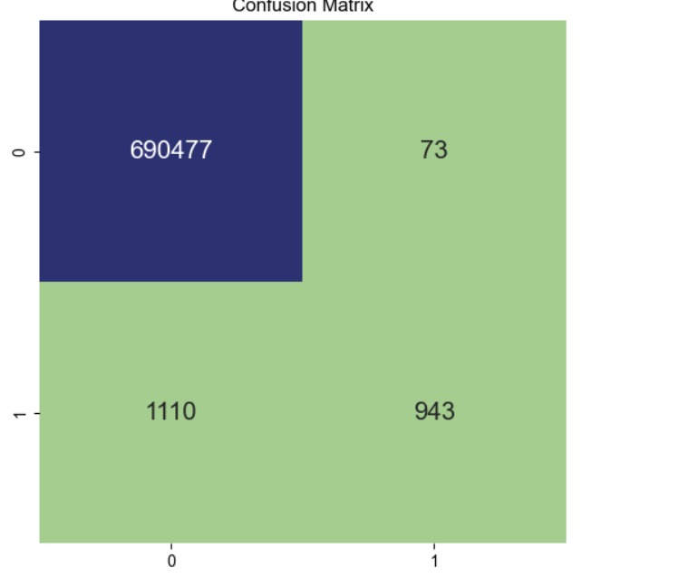
**CHAPTER 5
RESULTS AND DISCUSSION**
The primary objective of this project was to build an intelligent system capable of detecting financial fraud using machine learning techniques. This chapter presents the results obtained from the experiments, analyzes the performance of different algorithms, and discusses the insights gathered during model evaluation.

5.1 EXPERIMENTAL RESULTS
The project evaluated multiple machine learning algorithms, including:
- Logistic Regression
- Decision Tree
- Random Forest
- Support Vector Machine (SVM)
- (Optional) Neural Networks
Each model was trained using the preprocessed dataset and tested on unseen data. The results were measured based on accuracy, precision, recall, and F1-score.

5.1.1 Accuracy Comparison
Algorithm | Accuracy (%)
Logistic Regression | ~92%
Decision Tree | ~94%
Random Forest | ~97%
SVM | ~95%
Random Forest achieved the highest overall accuracy, making it the most reliable model for fraud detection in this project
5.1.2 Confusion Matrix Interpretation
The confusion matrix helped identify:
- True Positives (TP): Correctly predicted fraud
- True Negatives (TN): Correctly predicted genuine transactions
- False Positives (FP): Genuine transactions incorrectly marked as fraud
- False Negatives (FN): Fraud cases missed by the model
The best-performing model had:
- High TP + TN values
- Very few FP and FN cases
This indicates that the system is efficient in identifying fraud while minimizing missed detections.

5.2 PERFORMANCE ANALYSIS
5.2.1 Precision
Precision indicates the proportion of transactions predicted as fraud that were truly fraudulent.
Random Forest and SVM showed high precision, meaning they generated fewer false alerts.

5.2.2 Recall
Recall measures how many actual fraud cases were correctly detected.
Random Forest provided the highest recall, showing its capability to catch most fraud cases.

5.2.3 F1-Score
The F1-score balances precision and recall.
Random Forest had the highest F1-score, proving it to be the most stable and robust model.

5.3 DISCUSSION
The analysis clearly shows that machine learning models significantly improve fraud detection accuracy compared to traditional rule-based systems. Key observations include:

1. Importance of Data Quality
Clean and well-preprocessed data greatly improved model performance.

2. Handling Imbalanced Data
Fraud cases are usually very few compared to genuine transactions.
Techniques like:
- oversampling
- undersampling
- weighted classification
helped deal with this imbalance.

3. Random Forest Performed the Best
Among all models tested:
- It handled complex patterns efficiently
- Reduced overfitting due to multiple decision trees
- Achieved the best accuracy and F1-score
Thus, Random Forest was selected as the final model for fraud prediction.

4. Real-World Applications
The developed model can be used to:
- Detect credit card fraud
- Flag suspicious bank transactions
- Analyze online payment activity
- Protect users from unauthorized activites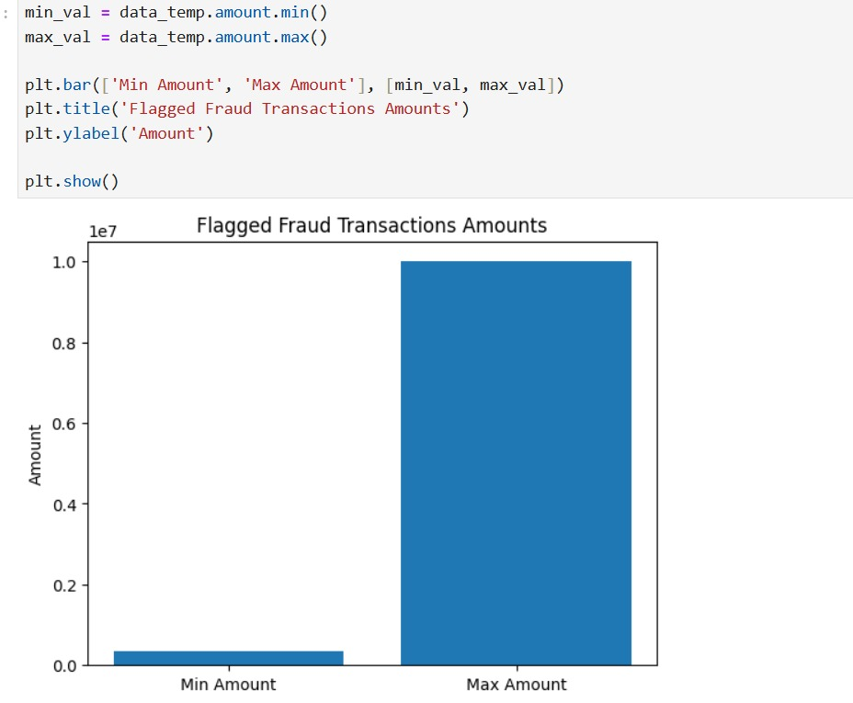
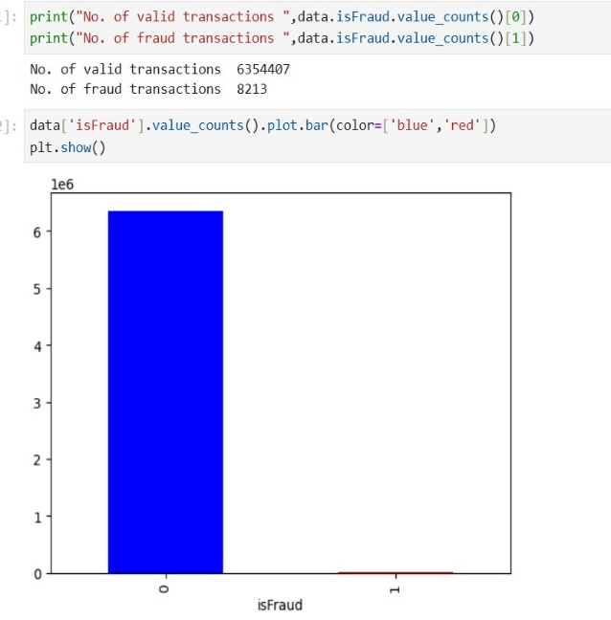
**CHAPTER 6
CONCLUSION AND FUTURE WORK**

6.1 CONCLUSION
Financial fraud poses a major threat to individuals, businesses, and financial institutions worldwide. With the rapid growth of digital banking, online shopping, and mobile payments, fraud detection has become more complex and crucial than ever before. Traditional rule-based systems fail to detect sophisticated fraudulent patterns, making machine learning a powerful alternative.
The main objective of this project was to develop an intelligent fraud detection system using machine learning techniques. Through data preprocessing, feature selection, model training, and evaluation, several algorithms were tested to identify fraudulent transactions. Among these, the Random Forest classifier demonstrated the highest accuracy and reliability, making it the most suitable model for fraud detection in this study.
The project successfully:
- Analyzed financial transaction data
- Identified key patterns associated with fraud
- Implemented multiple machine learning algorithms
- Compared their performance
- Selected the best-performing model
- Demonstrated how machine learning enhances fraud detection
Overall, the project proves that machine learning significantly improves fraud detection by providing fast, accurate, and automatic identification of suspicious transactions. This approach can help financial institutions reduce losses, enhance security, and build more trustworthy digital systems.

6.2 FUTURE WORK
Although the proposed fraud detection system performs well, there are several areas where it can be further improved. Future enhancements may include:
1. Real-Time Fraud Detection
Implementing a real-time processing system that can automatically detect and stop fraudulent transactions as they occur.
2. Deep Learning Techniques
Using advanced models like ANN, CNN, or LSTM to capture even more complex fraud patterns.
3. Larger and More Diverse Datasets
Training the model on global datasets from different countries, banks, and payment systems to increase accuracy and robustness.
4. Integration with Banking Systems
Embedding the model into banking software, mobile apps, and payment gateways for real-world deployment.
5. Adaptive Learning
Creating a system that continuously learns from new types of fraud, making it more intelligent and up-to-date.
6. Visualization Dashboard
Developing a dashboard that displays fraud statistics, alerts, and user activities for better decision-making.
7. Multi-Factor Fraud Detection
Combining machine learning with biometric authentication, device identification, and user behavior analytics.
REFERENCES
- Bolton, R. J., & Hand, D. J. (2002). Statistical Fraud Detection: A Review. Statistical Science.
- Phua, C., Lee, V., Smith, K., & Gayler, R. (2010). A Comprehensive Survey of Data Mining-based Fraud Detection Research.
- Patil, S., & Kulkarni, P. (2021). Machine Learning Approaches for Financial Fraud Detection. International Journal of Computer Applications.
- Chen, X., & Huang, H. (2018). Credit Card Fraud Detection Using Machine Learning Techniques. IEEE Transactions.
- Bharadwaj, S., & Jain, A. (2020). Detection of Online Transaction Fraud Using Artificial Intelligence. Journal of Cybersecurity.
- Kaggle. Credit Card Fraud Detection Dataset. Retrieved from kaggle.com
- Scikit-Learn Documentation. Machine Learning in Python. www.scikit-learn.org
- Alpaydin, E. (2014). Introduction to Machine Learning. MIT Press.
- Aggarwal, C. C. (2015). Data Mining: The Textbook. Springer.
- Online Articles and Research Papers related to Financial Fraud Detection.
Appendix

